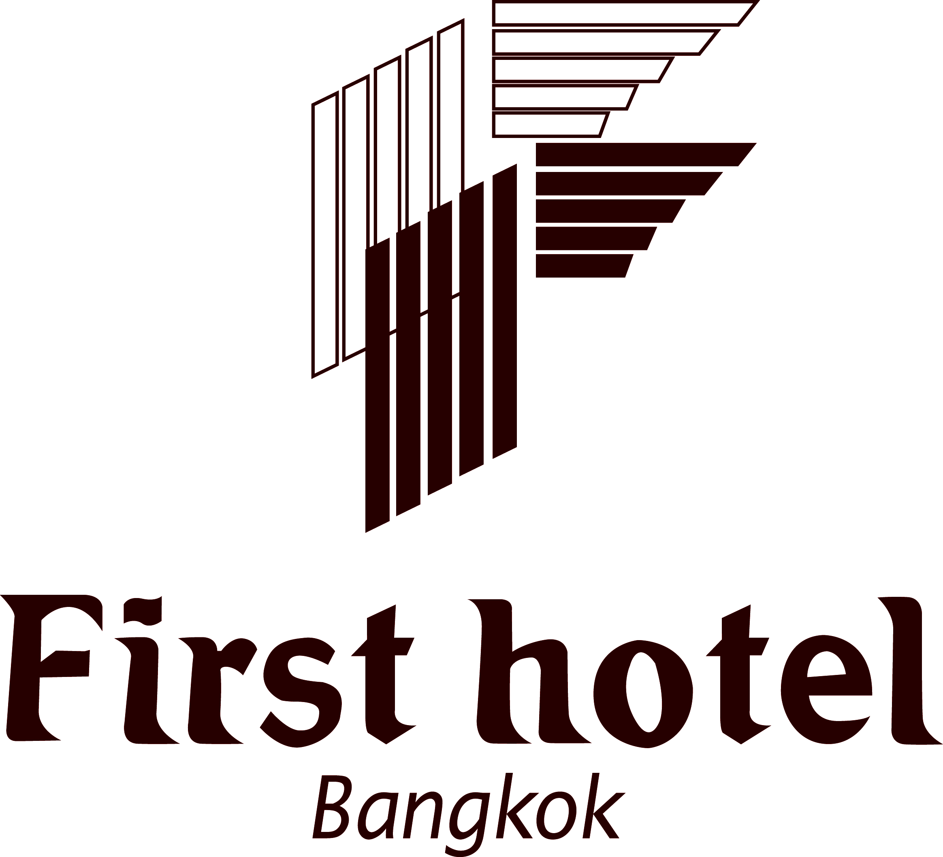

ROOM RESERVATION

AINTEC 2008, 18-20 November 2008
First Hotel Bangkok

Attention: Ms. Rachuda Kaewrueng or Suphitsara Boonrat (AIT)
Date: ___________________________________
Tel : (66 2) 255-0100-20, Fax. (66-2) 653-8048

From: ________________________________ Fax: ______________Tel: ___________________

Booked By: ____________________________________ (Blocked Letters)

Guest Name(s): ____________________________________________________________________________

Arrival Date: _________________________Departure Date: _________________________

Room Rates/Types: ◻ Smoking ◻ Non-smoking

◻ Superior/tower wing Bht. 1,800.-nett/room/night with breakfast
◻ Superior/main wing Bht. 1,700.-nett/room/night with breakfast

Guaranteed RSVN By Credit Card # _________________________
Expiry Date: _______________________

Type of Card: __________________________
Name of Card Holder: ________________________________

Signature: _____________________________________________________

Limousine Request: Bht. 1,500.-nett/car/one way

◻ Yes ◻ No : Airport-Hotel Flight Details/Date: ____________________________
◻ Yes ◻ No : Hotel-Airport Flight Details/Date: ____________________________

Please be informed that our airport representative will be holding a “First Hotel Bangkok” signboard and waiting at the existing gate according to your flight details to take care of you.

The non-utilized limousine transfers will be fully charged to Guest Account if cancellation is not made minimum four (4) hours prior to the flight arrival, as this fee is charged by the limousine company.

